Material flow description

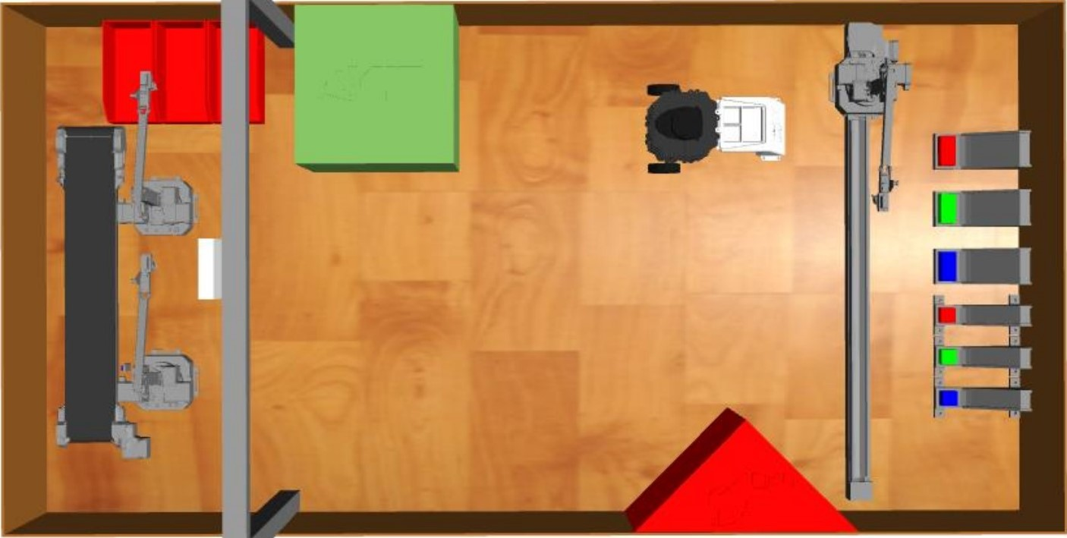

**1**

**3**

**2**

New order with specific number of objects:

1. Box Get Object from storage

a) Turtlebot moves to calibration point / calibrates its position  
b) Uarm1 moves in front of the right storage   
c) Uarm1 gets object and moves back in front of turtlebot  
d) Uarm1 puts Object on the turtlebot into the foreseen boxes  
e) If there are more Objects left the order and turtlebot isn’t full yet: repeat from step b)

2. Box Move Object to the destination area

a) Turtlebot moves itself to the Uarm2  
b) Turtlebot positions itself in front of Uarm2 so Uarm2 can reach the objects

3. Box Put Object in the storage

a) Uarm2 takes object from turtlebot  
b) Uarm2 puts the object on the conveyor  
c) Conveyor moves the object to the other side so that Uarm3 can reach the object  
d) Uarm3 takes object from conveyor and puts it in the right storage  
e) If there are more objects on the turtlebot: repeat from step a)

Material Flow:

Uarm1 Turtlebot Uarm2 conveyor Uarm3

Move

Get

Put

Put

Get

Move self

Put/Get

Move self

Get